Weekly Construction Progress Report – Week 21
Harrow Bay Offshore Wind · 18 May – 24 May 2026
Elena Márquez · 25 May 2026 · HB-PM-RPT-2026-W21

1. Summary
1 monopile (HB-A07) was installed this week, bringing the total to 7 of 40. The foundation campaign is on the Rev 2 baseline. Waiting on weather amounted to 8 hours.
Area | Status | Comment
Overall schedule | Green | 7/40 monopiles vs. 7 planned
Foundations | Green | TPs installed: 7
Offshore substation | Green | Fabrication / load-out
Cables | Green | Manufacturing on schedule
HSE | Amber | Near miss reported

2. Progress
Metric | This week | Cumulative | Plan (cum.) | Variance
Monopiles installed | 1 | 7 | 7 | +0
Transition pieces installed | 1 | 7 | – | –
Waiting on weather (h) | 8 | 132 | – | –
Persons on board (avg.) | 94 | – | – | –
Man-hours MV Sea Atlas | 7,602 | 57,444 | – | –
Lost time injuries | 0 | 0 | 0 | 0
Recordable injuries | 0 | 0 | – | –
Near misses reported | 1 | 2 | – | –
HSE observation cards | 26 | – | – | –

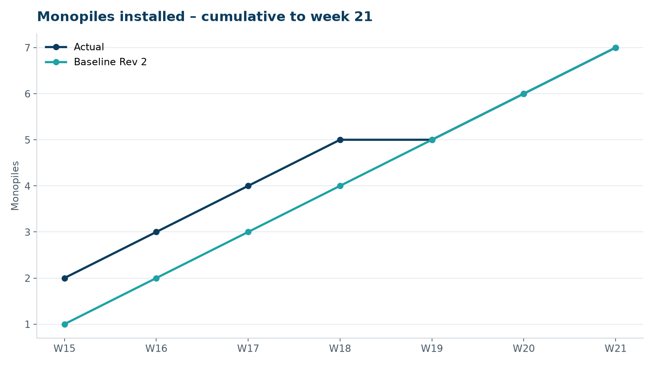
Figure 1 – Monopile installation progress, W15 to W21

3. Key activities this week
- HB-A07 installed on 21 May.
- Lars Henriksen (Halden Turbine Systems) visited Eastholm to agree the 2027 turbine pre-assembly area on Quay 3.
- Interface meeting on transition piece flange tolerances for the HTS-12 tower base.

4. Health and safety
No lost time injuries. One near miss reported (minor; closed out on board). 26 observation cards submitted; top theme: hot work permits.

5. Environment
- HB-A07: peak 158.0 dB SEL at 750 m (compliant); pre-piling search clear, soft start on time.

6. Issues and risks
- HB-RISK-001 weather: 8 h downtime this week.

7. Look-ahead next week
Install HB-A08 and TP HB-A07.
Prepared by Project Controls (Gareth Lewis); approved by Elena Márquez. Distribution: project team, Steering Committee, Halden Turbine Systems, Lenders' Technical Adviser.

